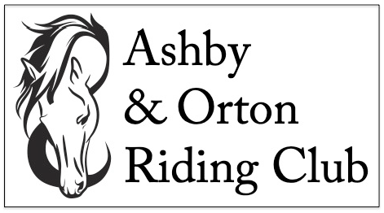
EVENT ENTRY FORM
Please use one entry form per horse and rider combination
Rider Details
Rider/handler name
Date of birth | If relevant to class
Horse/pony name
Contact telephone number
Email address
Address

Entry Details
DRESSAGE EVENT SHOWING EVENT EVENT DATE:
Please delete as appropriate
Are you entering the open or restricted class? (see note below) OPEN / RESTRICTED
Which tests/classes do you wish to enter?
Total entry fees enclosed  Dressage: Members £11 per test Non-members £14.00 per test  Showing: Members £6.00 per class Non-members: £8.00 per class | £
Note: (Restricted – never to have been placed 1st or 2nd as a horse/rider combination at an A&O event, excluding at Intro level)
Disclaimer
Legal Liability: Neither the club, not any person acting on its behalf, will accept liability for any loss, damage, accident injury or illness to horses, ponies, riders, spectators or any other person or property whatsoever. All vehicles are parked at the owner's risk. No responsibility will e accepted for damage to or loss from vehicles parked on the show ground.
Signature: If under 16 years, signature of parent or guardian
Date:

Entries close 4 DAYS prior to the event. Please note ALL entry forms and correct fees MUST be received by Mandy Forsyth by the stated closing date. Entry forms will not be accepted unless accompanied by the correct fees. Please make cheques payable to Ashby and Orton Riding Club.
Entries to: Mrs Mandy Forsyth, 138 Spring Cottage, Overseal, Swadlincote, Derbyshire DE12 6ND. Completed entry forms with fees may also be dropped off at Sealwood Saddlery. Due to Covid restrictions, we are NOT operating a “pay on the day” system this year.
Dressage Entry Times: Times will be issued by text 2 days prior to the event.
>> THANK YOU FOR SUPPORTING ASHBY AND ORTON RIDING CLUB <<

