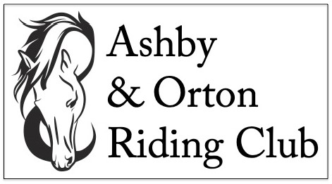
EVENT ENTRY FORM – 2022 Season
Rider/Handler name: ………………………………………………………………………………….
Date of Birth (if relevant to class): ………………………………………………………………
Horse/Pony Name: …………………………………………………………………………………….
Contact phone number: …………………………………………………………………………….
Email address: …………………………………………………………………………………………..
Address: ……………………………………………………………………………………………………
………………………………………………………………………………………………………………….
Member / Non-Member (delete as appropriate)
Class Date: ……………………………. Showing/Dressage/Both (delete as appropriate)
I wish to enter the following class(es): ………………………………………………………
………………………………………………………………………………………………………………….
For dressage classes: Open / Restricted* Junior / Senior**
Total entry fees enclosed: ………………………………………………………………………..
* Rider never to have been placed 1st or 2nd in a previous A&O dressage class
** Rider 16 years or under on January 1st 2022

Disclaimer
Legal Liability: Neither the club, not any person acting on its behalf, will accept liability for any loss, damage, accident injury or illness to horses, ponies, riders, spectators or any other person or property whatsoever. All vehicles are parked at the owner's risk. No responsibility will be accepted for damage to or loss from vehicles parked on the show ground.
Signature: Juniors, signature of parent/guardian
Date:

Entry forms will not be accepted unless accompanied by the correct fees.
Please make cheques payable to Ashby and Orton Riding Club.
Please send completed forms to: Mandy Forsyth, 138 Spring Cottage, Overseal, Swadlincote, Derbyshire DE12 6ND.
… or … Call, Message or Text Mandy on 07581 680740

