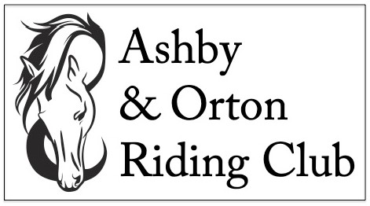
MEMBERSHIP APPLICATION FORM - 2023
Member's details
Name
Contact phone number
Email address
Address

Membership Type
Junior | 16 years and under | £20.00
Senior | 17 years and over | £26.00
Total membership fees enclosed |  | £

Disclaimer
Legal Liability: Neither the club, not any person acting on its behalf, will accept liability for any loss, damage, accident injury or illness to horses, ponies, riders, spectators or any other person or property whatsoever. All vehicles are parked at the owner's risk. No responsibility will be accepted for damage to or loss from vehicles parked on the show ground.
Signature: Juniors, signature of parent/guardian
Date:

Membership forms will not be accepted unless accompanied by the correct fees.
Please make cheques payable to Ashby and Orton Riding Club.
Please send completed forms to: Mr Rob Forsyth, 138 Spring Cottage, Overseal, Swadlincote, Derbyshire DE12 6ND.
>> Thank you for joining The Ashby and Orton Riding Club. <<

